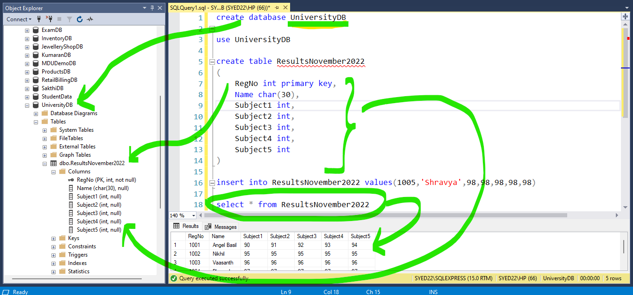

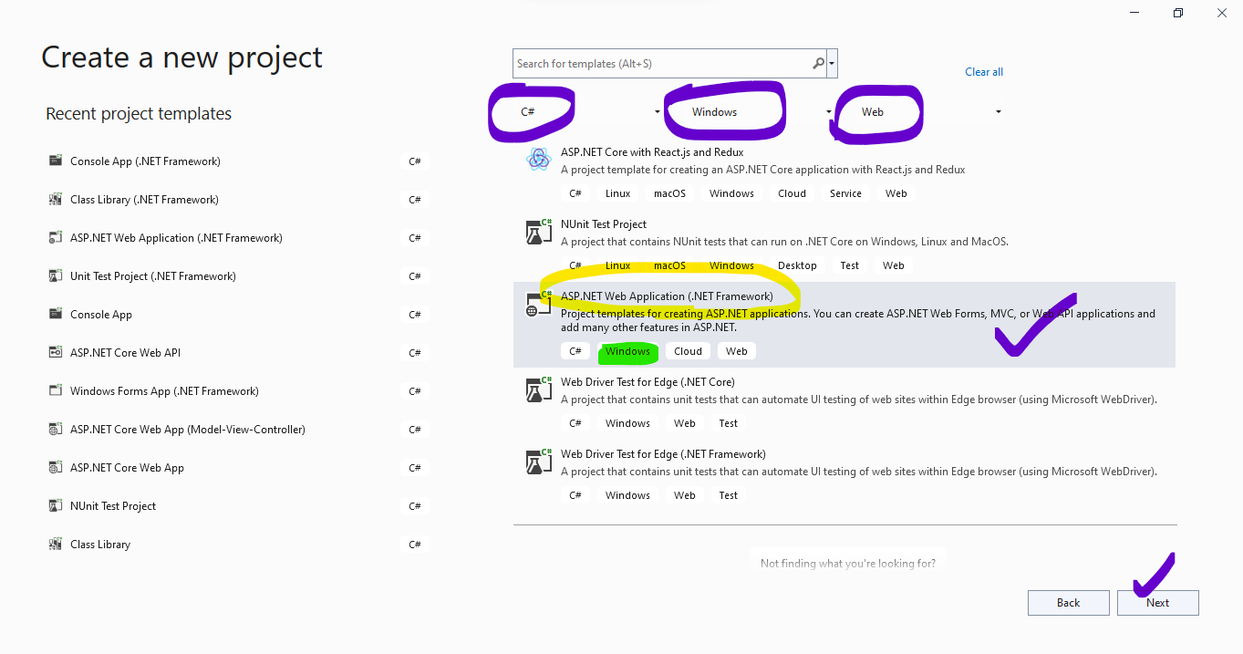

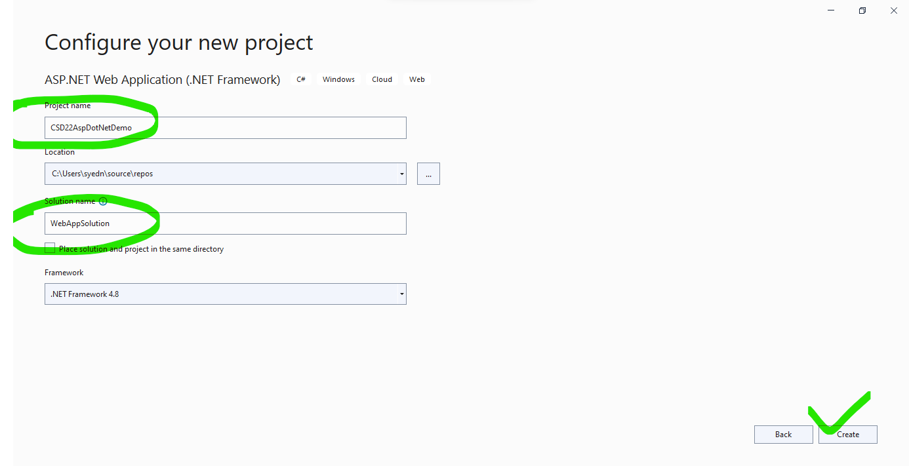

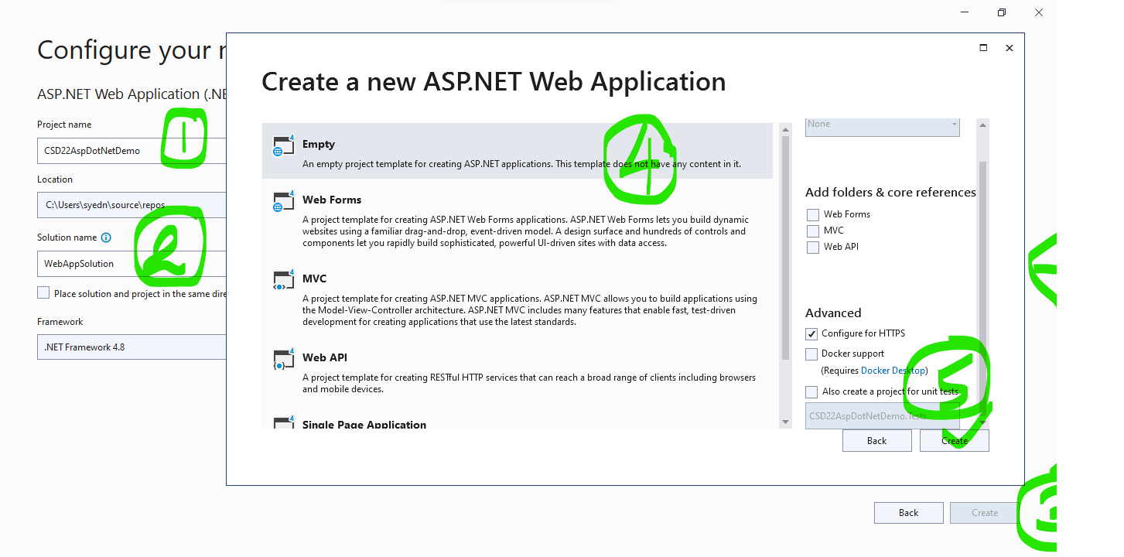

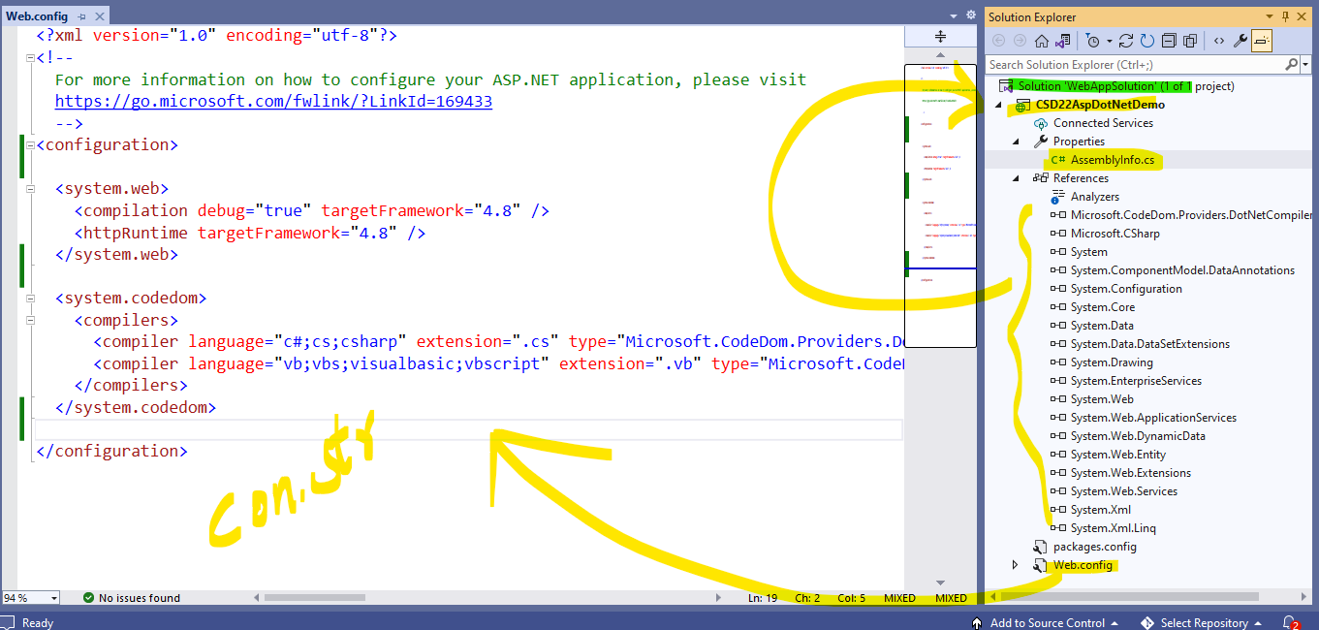

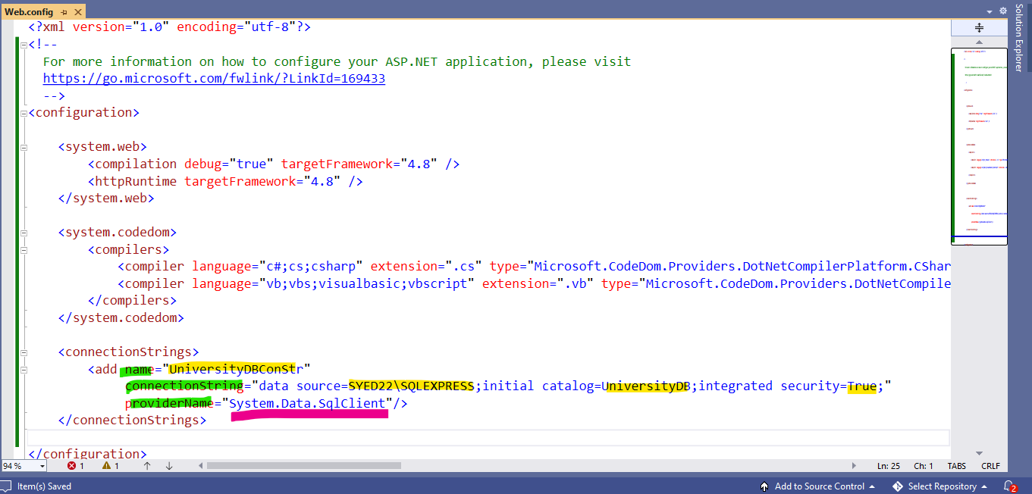

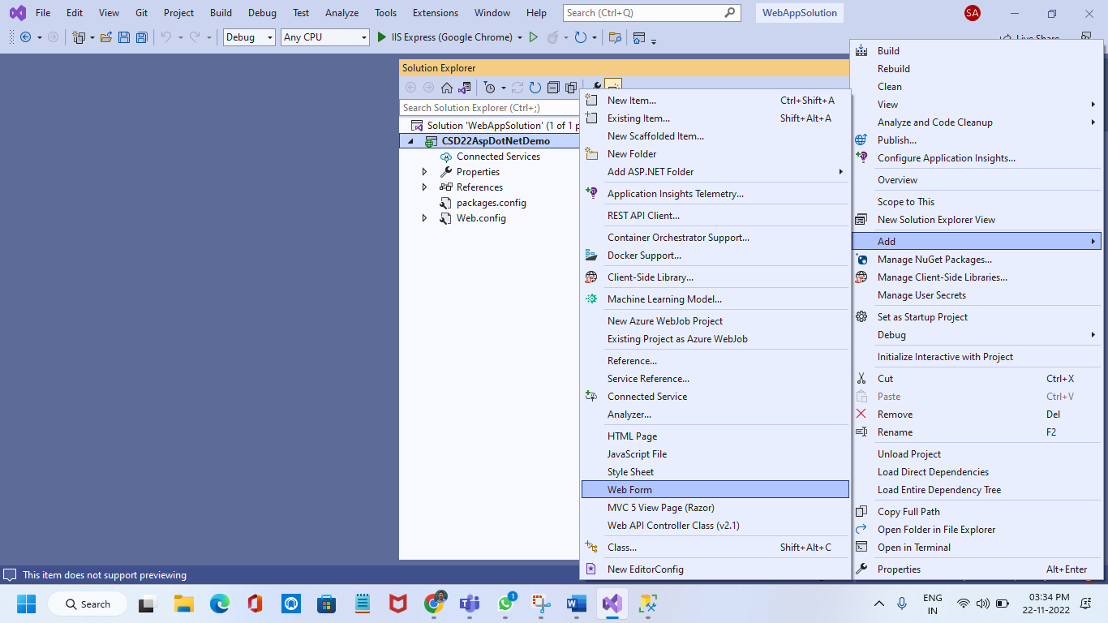

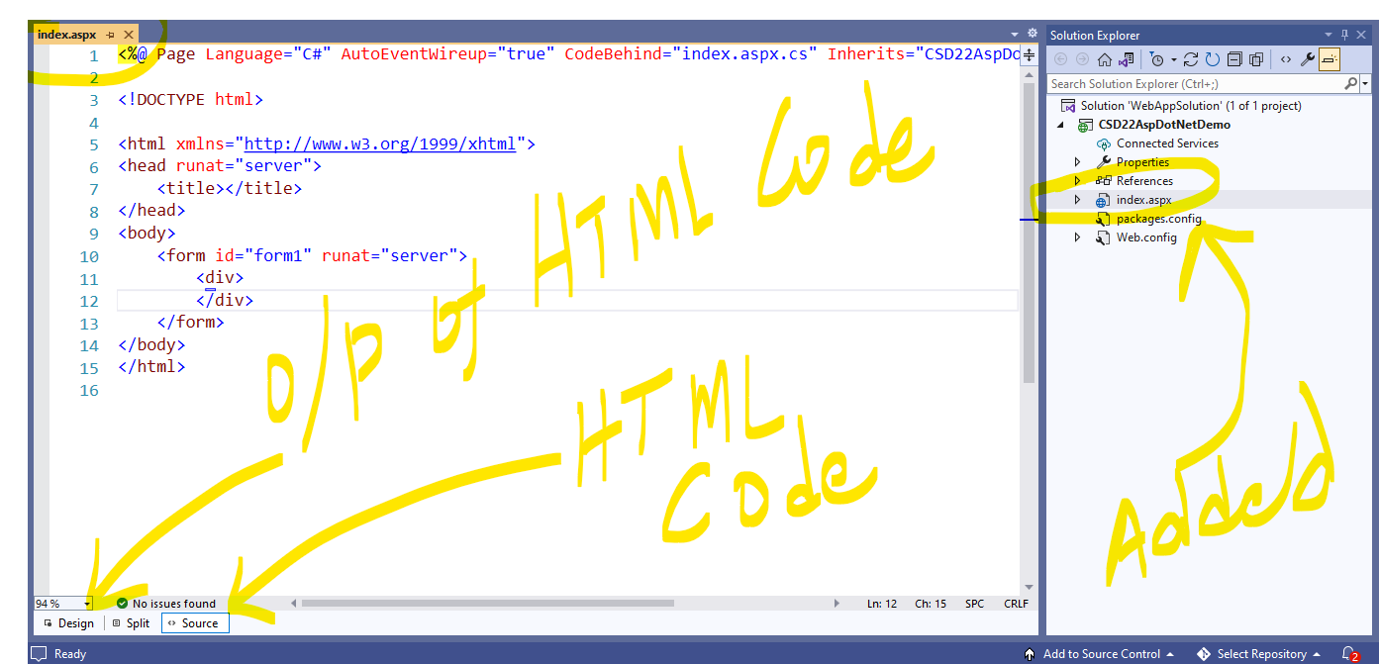

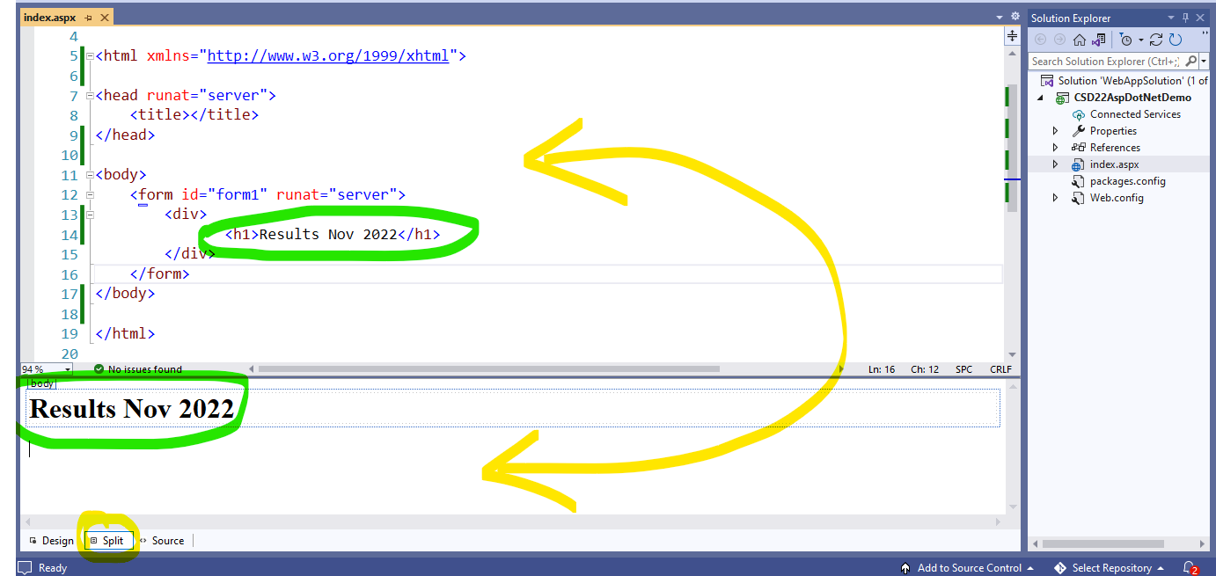

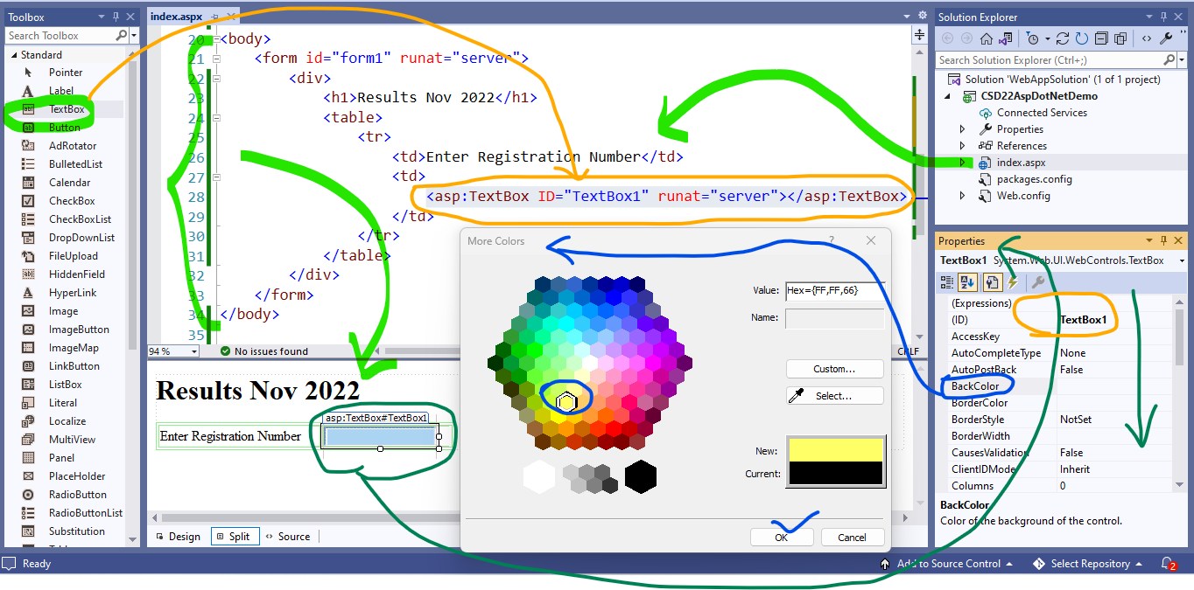

Add the needed controls to design UI as below and Provide appropriate Names to controls with prefix

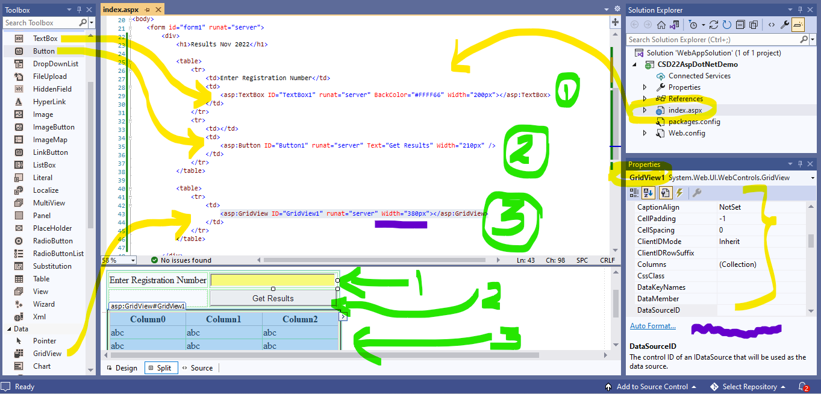

<%@ Page Language="C#" AutoEventWireup="true" CodeBehind="index.aspx.cs" Inherits="CSD22AspDotNetDemo.index" %>

<!DOCTYPE html>

<html xmlns="http://www.w3.org/1999/xhtml">

<head runat="server">

<title>Madras University Results</title>

<style>

table {

width: auto;

}

table, tr, td {

border: 1px solid lightgreen;

}

</style>

</head>

<body>

<form id="form1" runat="server">

<div>

<h1>Results Nov 2022</h1>

<table>

<tr>

<td>Enter Registration Number</td>

<td>

<asp:TextBox ID="txtRegistrationNumber" runat="server" BackColor="#FFFF66" Width="200px"></asp:TextBox>

</td>

</tr>

<tr>

<td></td>

<td>

<asp:Button ID="btnGetResults" runat="server" Text="Get Results" Width="210px" />

</td>

</tr>

</table>

<table>

<tr>

<td>

<asp:GridView ID="grdResults" runat="server" Width="380px"></asp:GridView>

</td>

</tr>

</table>

</div>

</form>

</body>

</html>

|  |  |  |
| --- | --- | --- |
|  | After baby is born: what to expect | Raising Children Network | 10 Incredible Buffalo Facts - AZ Animals |
| Chaning Properties of controls | Naming the controls (Imp) | Difference bw Name and Text Prop |

Run the application

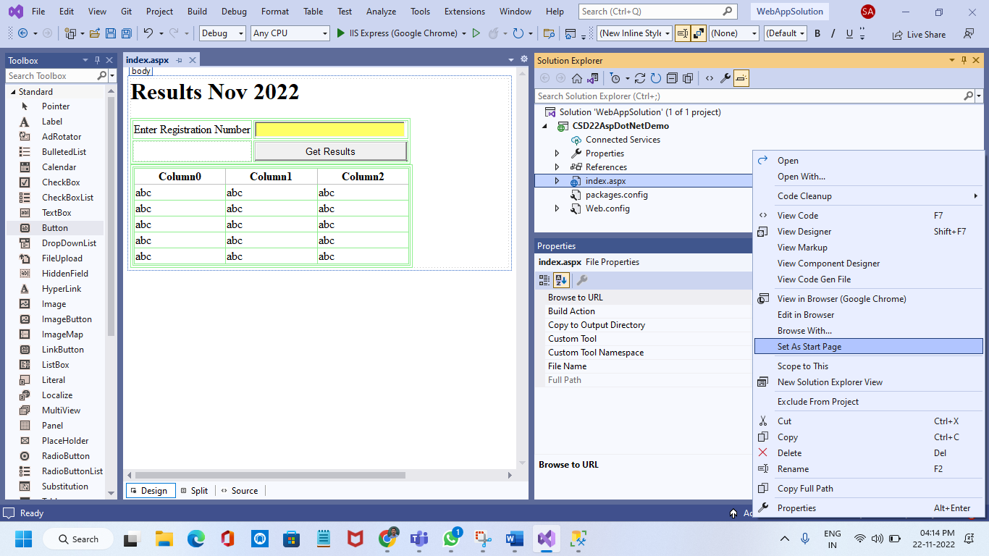

IISExpress – Microsoft Local webserver to manage the execution of web applications created in visual studio

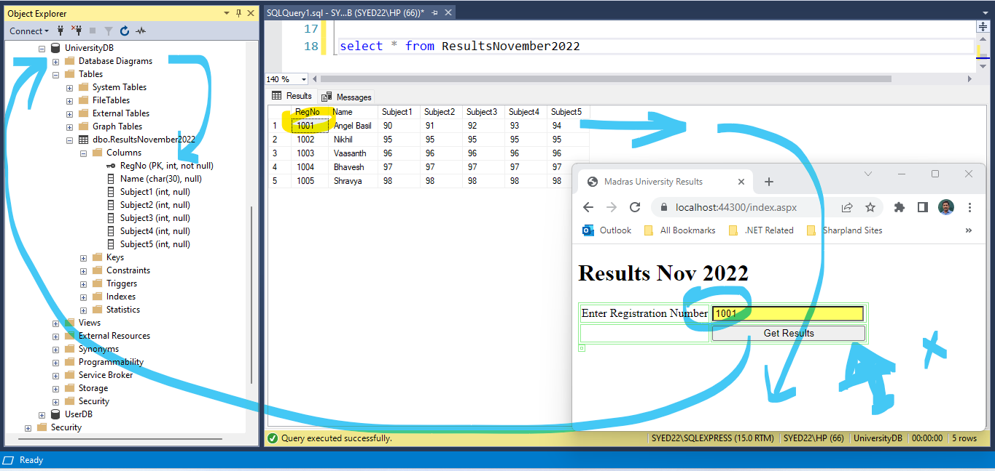

Now, we are going to add **Server-Side code** to fetch the record from DB by sending Registration Number

Add following Stored Procedure in SQL Server

create procedure spGetResultsByRegNumber

**@RN** as int

as

begin

select * from ResultsNovember2022

where RegNo**=@RN**

end

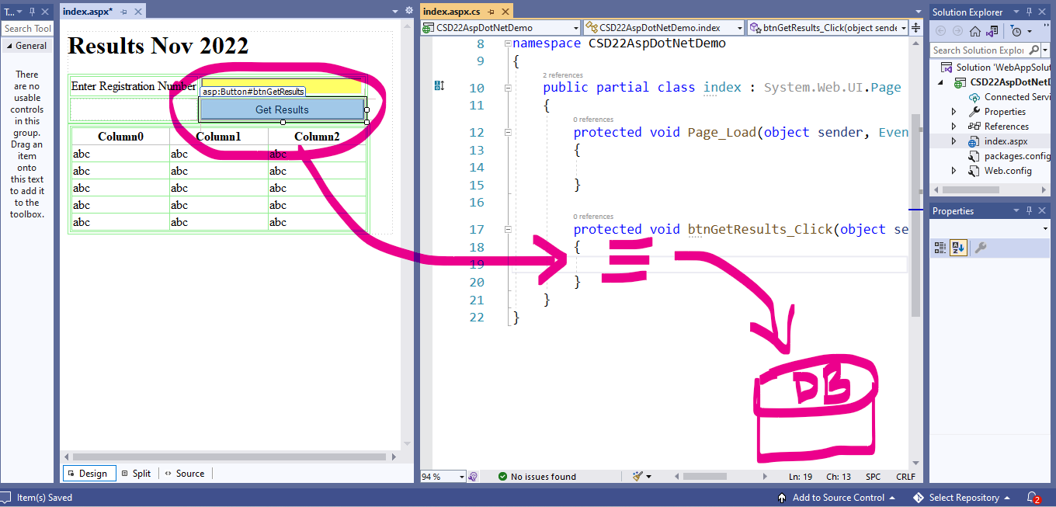

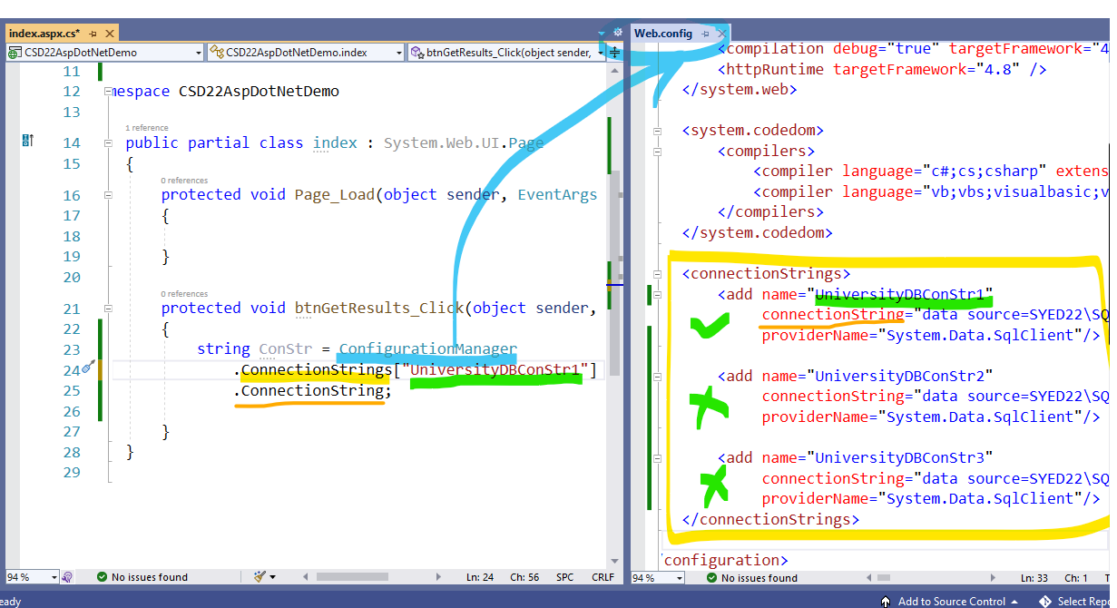



Initializing adapter by command object is like boarding a bus in boat to cross the river or sea

protected void btnGetResults_Click(object sender, EventArgs e)

{

//Step 0

string ConStr = ConfigurationManager.ConnectionStrings["UniversityDBConStr1"].ConnectionString;

//Step1

SqlConnection con = new SqlConnection(ConStr);

con.Open();

//Step2

SqlCommand cmd = new SqlCommand("spGetResultsByRegNumber", con);

cmd.CommandType = System.Data.CommandType.StoredProcedure;

cmd.Parameters.AddWithValue**("@RN",** txtRegistrationNumber.Text);

SqlDataAdapter adapter = new SqlDataAdapter();

adapter.SelectCommand = cmd;

//Step3

DataSet ds = new DataSet();

adapter.Fill(ds, "tabrecs");

//Step4

grdResults.DataSource = ds;

grdResults.DataBind();

}

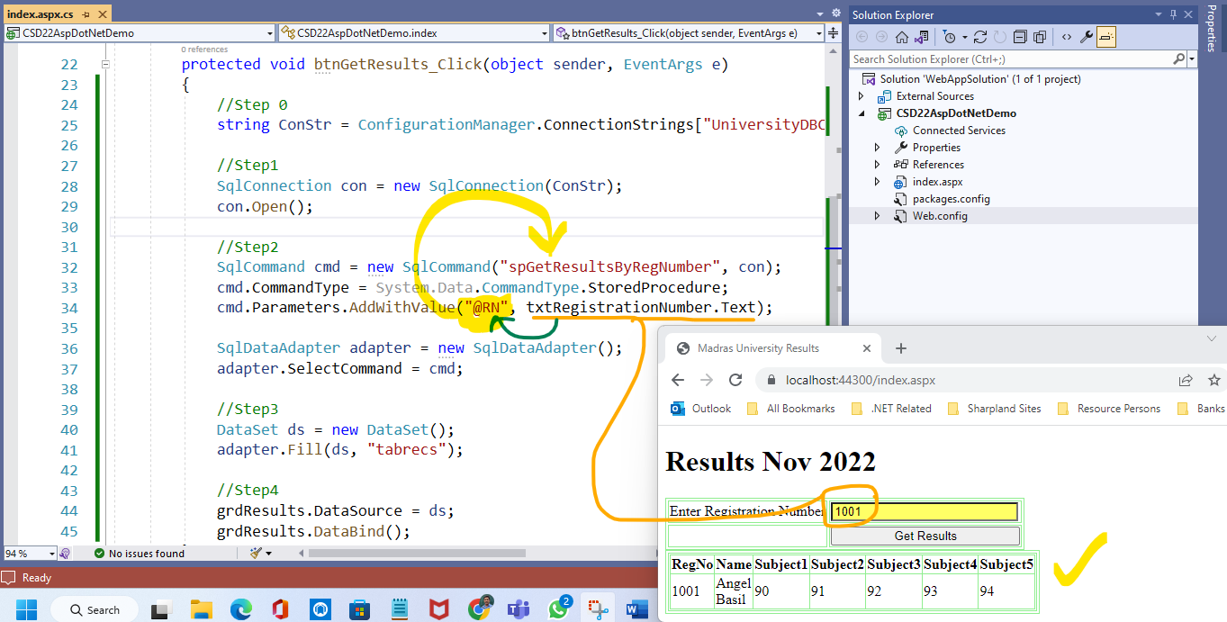

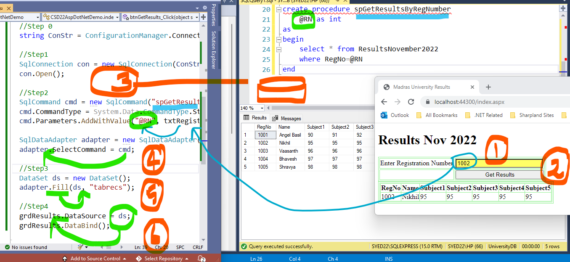

Add a webform in your project (to Demonstrate Data Insertion)

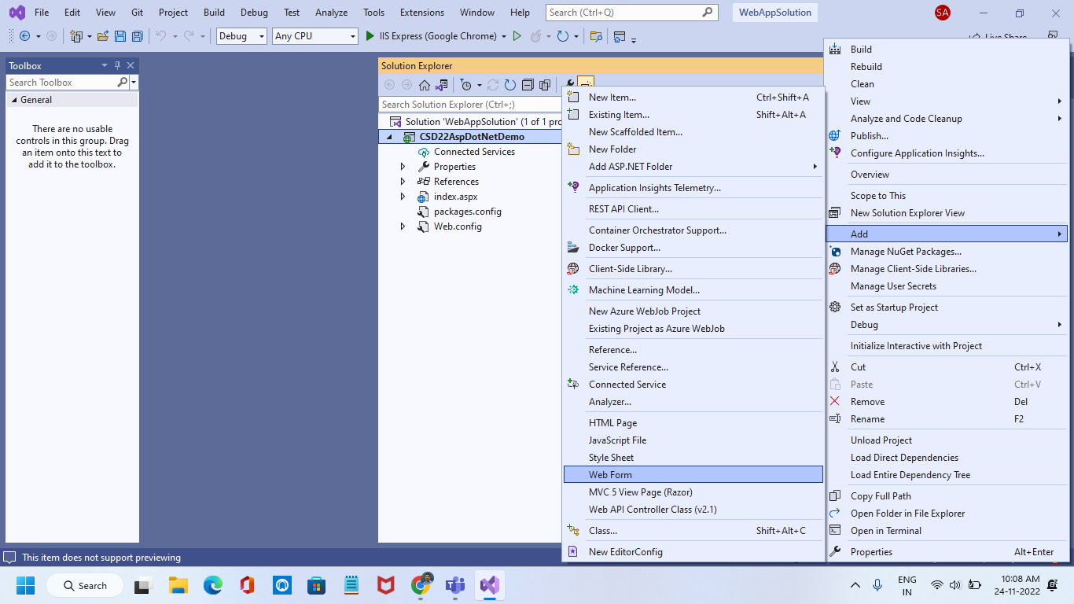

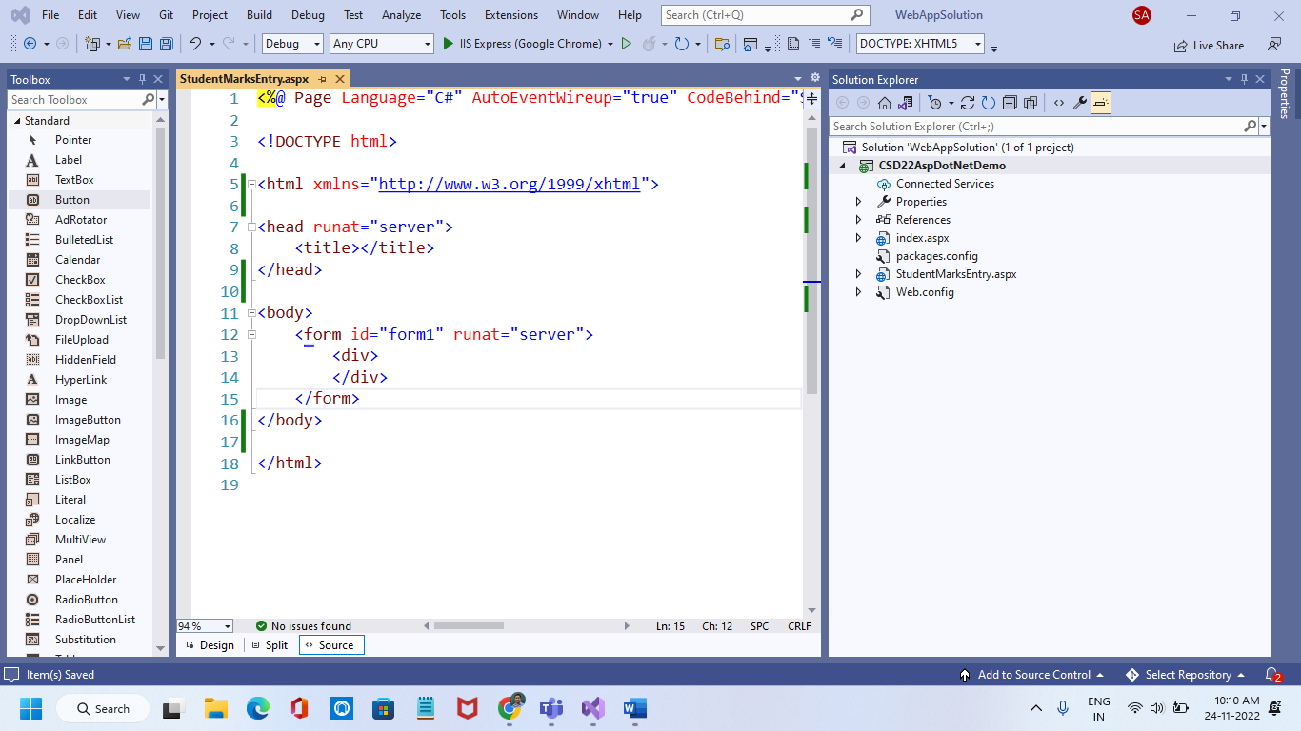

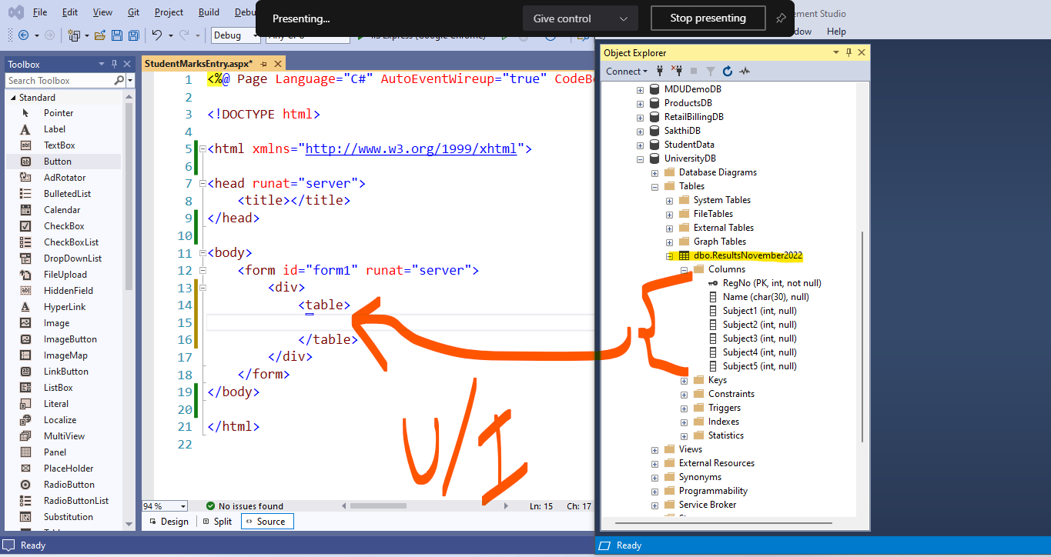

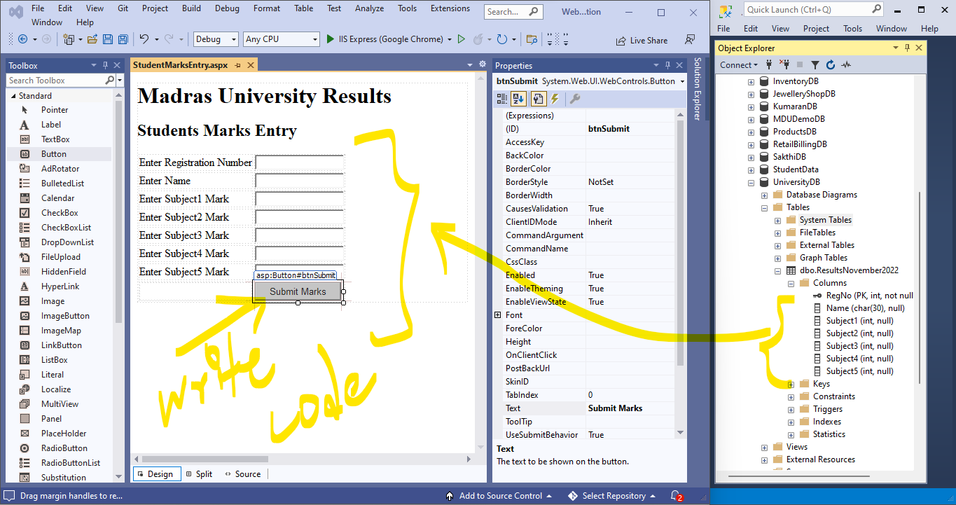

<%@ Page Language="C#" AutoEventWireup="true" CodeBehind="StudentMarksEntry.aspx.cs" Inherits="CSD22AspDotNetDemo.StudentMarksEntry" %>

<!DOCTYPE html>

<html xmlns="http://www.w3.org/1999/xhtml">

<head runat="server">

<title>Students Marks Entry</title>

</head>

<body style="background-color:darkcyan;color:white;">

<form id="form1" runat="server">

<div>

<h1>Madras University Results</h1>

<h2>Students Marks Entry</h2>

<table>

<tr>

<td>Enter Registration Number</td>

<td>

<asp:TextBox ID="txtRegNo" runat="server"></asp:TextBox>

</td>

</tr>

<tr>

<td>Enter Name</td>

<td>

<asp:TextBox ID="txtName" runat="server"></asp:TextBox>

</td>

</tr>

<tr>

<td>Enter Subject1 Mark</td>

<td>

<asp:TextBox ID="txtSubject1" runat="server"></asp:TextBox>

</td>

</tr>

<tr>

<td>Enter Subject2 Mark</td>

<td>

<asp:TextBox ID="txtSubject2" runat="server"></asp:TextBox>

</td>

</tr>

<tr>

<td>Enter Subject3 Mark</td>

<td>

<asp:TextBox ID="txtSubject3" runat="server"></asp:TextBox>

</td>

</tr>

<tr>

<td>Enter Subject4 Mark</td>

<td>

<asp:TextBox ID="txtSubject4" runat="server"></asp:TextBox>

</td>

</tr>

<tr>

<td>Enter Subject5 Mark</td>

<td>

<asp:TextBox ID="txtSubject5" runat="server"></asp:TextBox>

</td>

</tr>

<tr>

<td></td>

<td>

<asp:Button ID="btnSubmit" runat="server" Text="Submit Marks" OnClick="btnSubmit_Click" />

</td>

</tr>

<tr>

<td colspan="2">

<asp:Label ID="lblMsg" runat="server" Text="Welcome user..." Font-Bold="True" ForeColor="Yellow"></asp:Label>

</td>

</tr>

</table>

</div>

</form>

</body>

</html>

Use UniversityDB

create procedure spSaveMarks

@RegNo int,

@Name char(30),

@Subject1 int,

@Subject2 int,

@Subject3 int,

@Subject4 int,

@Subject5 int

as

begin

insert into ResultsNovember2022

values(@RegNo,@Name,@Subject1,@Subject2,@Subject3,@Subject4,@Subject5)

end

sp_helptext spSaveMarks

